**Robotics I – Project 5 Fall 2018 – Due Monday Oct 1, in class**

**Line and Circle Following**

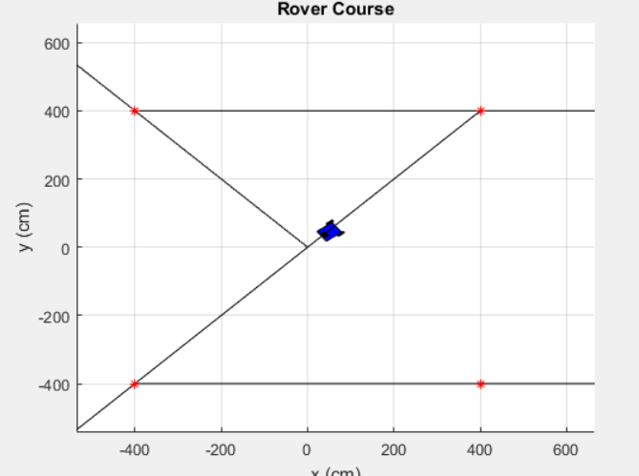

**Project Assignment: Develop and implement code to control our rover in order to follow a pre-defined waypoint list (or path). Use the functions contained in this folder, and assume a constant velocity specified in the same way as the last project. Also, use your line following and circle following functions created in project 4 and all of the other support functions necessary.**

**There are two TODO sections**

1. **Modify the code in the WaypointFollowing_throughPoint.m function in order to control the rover to follow the waypoints going through each waypoint before transitioning to the next.**
2. **Modify the code in the WaypointFollowing_roundCorner.m function in order to control the rover to follow the waypoints. Except now, instead of going through the waypoint, control a smooth transition between waypoint lines using the fillet method discussed in class.**